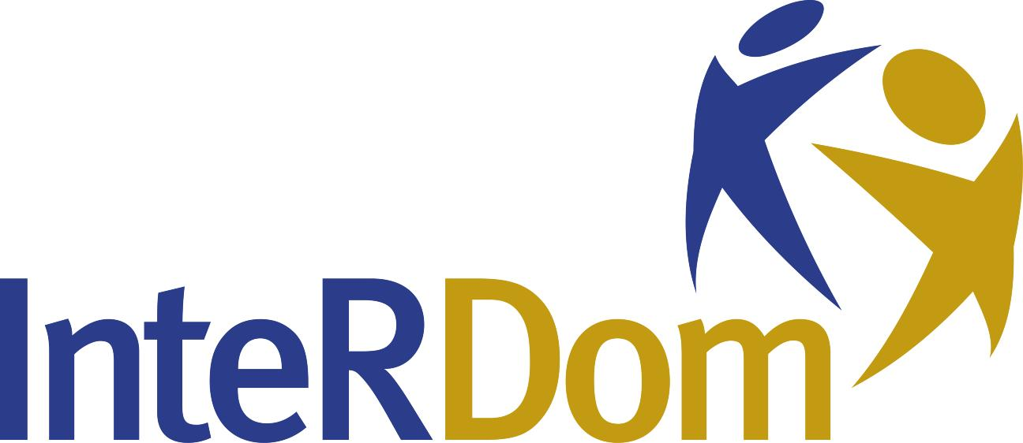
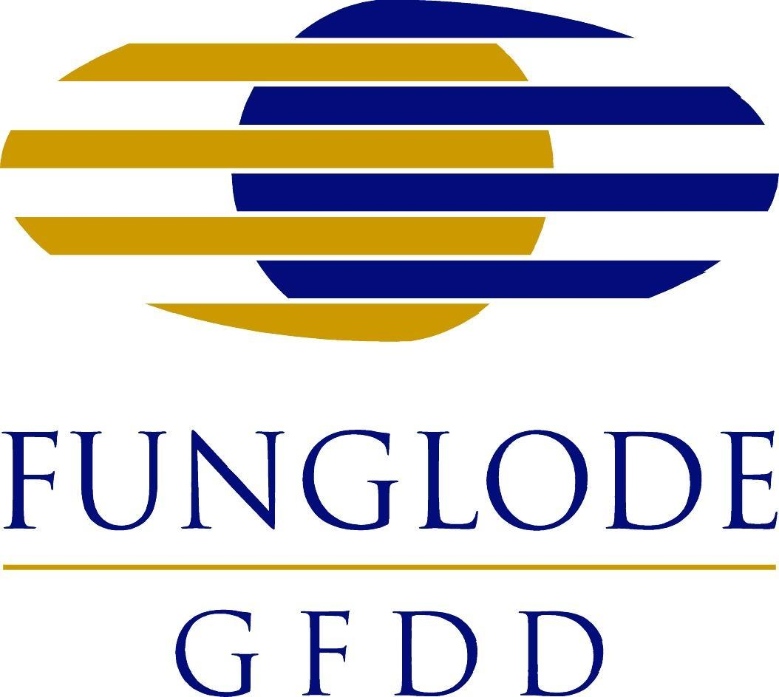


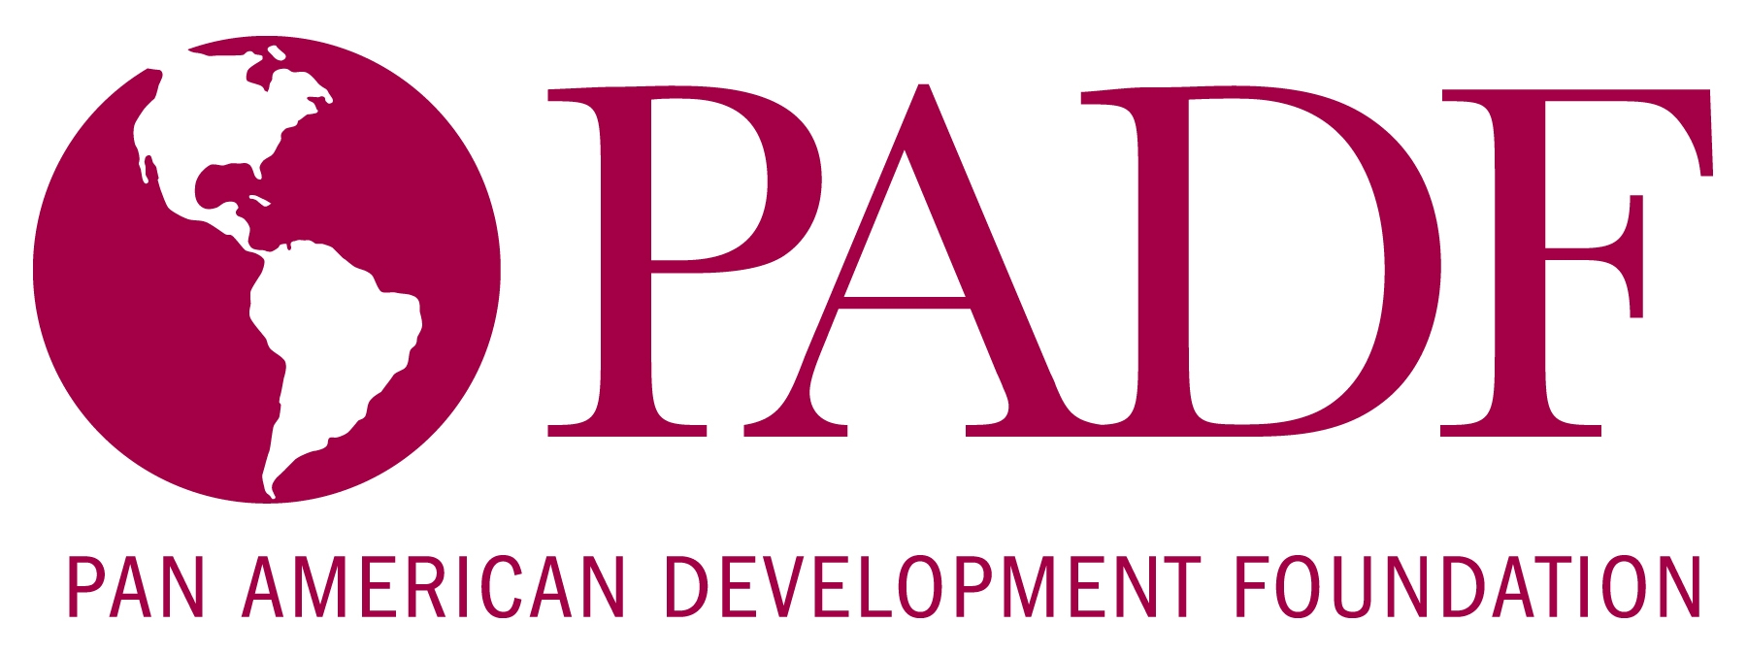

Seminar: “Aspects Relative to Haitian Immigrants in the Dominican Republic”

Monday, July 28, 2008

The internship program, InteRDom, in partnership with the Pan American Development Foundation, presents as part of its 2008 Summer Academic Program, “Aspects Relative to Haitian Immigrants in the Dominican Republic.” The event culminates July 30th with the inauguration of “The Dominican-Haitian Global Forum,” taking place at FUNGLODE Headquarters.
The purpose of the seminar is to provide greater insight into the lives of Haitians in the Dominican Republic and the cultural perceptions held by nationals of both countries. The event will include a presentation by Fulbright Scholar and Columbia University Ph.D. Candidate, Kiran Jayaram, who is currently conducting research on topics related to immigration at the Embassy of the United States’ Franklin Center.
The Pan American Development Foundation, established in 1962 through an agreement between the Organization of American States (OAS) and the private sector, fosters alliances between communities and public, private and non-profit institutions, with the objective of positively contributing to economic and social development throughout the Americas. Recently, PADF has developed the program, “Nuestra Frontera,” in collaboration with USAID.
The Forum
“The Dominican-Haitian Global Forum” is an initiative of GFDD and FUNGLODE’s Center for Documentation and Knowledge Management, which seeks to promote social debate and intercultural exchange. The event will feature the participation of Historians, Bernardo Vega and Dieudonn Fardien.
InteRDom, an initiative of Global Foundation for Democracy and Development (GFDD) and Fundación Global Democracia y Desarrollo (FUNGLODE), is the premier internship and academic study program in the Dominican Republic. The Program offers international students the opportunity to obtain professional experience by interning with Dominican organizations and businesses related to their field of study, complemented by courses and seminars at local universities.
Since its establishment in 2005, InteRDom has had interns from over 30 international universities. This summer’s interns represent the following universities: Fordham University, Amherst University, Syracuse University, Stony Brook University, and Science Po y el Instituto de Estudios Políticos de Toulouse (France).
Monday, July 28, 2008
PROGRAM

Moderator: Nathanael Concepción, Project Director, United Nations Association of the Dominican Republic (ANU-RD)

I. El mercado, diferenciación social, y ambivalencia: la gente de Haití en Santo Domingo
Presenter: Kiran Jayaram, Columbia University Ph.D Candidate in Anthropology and Fulbright Scholar
6:40 pm - 7:00 pm

The presentation offers answers to the question: How are immigrants impacted by the process of international migration to urban zones? The content of the presentation is based on long-term research and the experiences of people that immigrate to the Dominican Republic to Haiti.

II. Tourism and Migration: The Cases of Bávaro, Veron and Punta Cana
Presenter: Juan Carlos Sánchez, Executive Director, Cluster Turístico La Altagracia.

7:05 pm - 7:35 pm

The presentation explores Haitian immigration in the tourist zones of the region of Este in the Dominican Republic. It features insights from representatives from the Este Hotels Association and Fundación Natura.

III. Perceptions: The Treatment of Press in the Dominican Republic and Haiti
The Results of a Study Realized in the Border Zones
Presenters: Cesáreo Guillermo, Regional Director, and Michela Da Rodda, Administrative Assistant and Research Assistant, of "Fwontyè Nou - Nuestra Frontera," Pan American Development Foundation (PADF)
7:40 pm - 8:10 pm

The presentation examines the news stories that receive the most attention: What stories about Haitians receive the most headlines in the Dominican Republic? What stories about Dominicans receive the most attention in Haiti? Speakers present the results of a study realized in the Dominican border zones on how Dominicans in the region perceive Haitians.

IV. Questions and Answer Session 8:10 pm – 8:30 pm
Inter-exchange with civil society representatives.

ABOUT THE PRESENTERS

Kiran Jayaram
Kiran is a doctoral candidate in anthropology at Columbia University in New York. He completed a masters degree in applied anthropology at Columbia University's Teachers College. He also holds a masters degree in Latin American Studies from the University of Kansas, and a bachelors degree in mathematics from the University of Kansas. He was selected to work for the Summer Institute for Research Design by the National Science Foundation in 2005. He has received numerous awards and research scholarships, including: the Fulbright Student Fellowship; an award from Columbia Unversity's Teachers College's Office of Policy and Research; scholarships from the University of Kansas' Latin American Studies Center and Anthropology Department, the University of Florida and Columbia University; an award from the University of Kansas; and an award from the Haitian Studies Institute at the University of Kansas. Mr. Jayaram has participated in the 2005 and 2007 annual meetings of the Association of Caribbean Studies. In 2007, he also participated in the annual meetings of the United States Anthropology Association and the Society for Applied Anthropology. In addition to academic seminars, Jayaram has also participated in a variety of community forums, such as the Margaret Mead International Film Festival. His publications include: "One Time Essay" (2002) for the Institute of Haitian Studies, a collection of reviews published in 2003, 2004 and 2007; "The role of anthropology in the development of software" (2007); and a column for the Society of Applied Anthropology Bulletin (2007 to the present). In addition to his academic work, Jayaram also enjoys developing his practice of Hinduism. He is currently working on translating the Bhagavad Gita into Haitian Creole.

Juan Carlos Sánchez
He has worked as the Head of the Hotel Natura Park's Auditing Department for over 10 years. He has participated in the design of a management plan for the protected area of Bávaro Lake, one of the preservation initiatives of the tourism boulevard of Cabeza de Toro and disaster preparation workshops for communities located in tourist areas. He is currently the Executive Director of Clúster Turístico La Altagracia; President of Fundación Ecológica y Social Natura Park; Director of Clusters by USAID and CNC; as well as the Secretary of the Committee for Risk Management and Business Continuity for the Municipal District of Verón/Bávaro, as part of an agreement between the Este Hotel Association and the Pan American Development Foundation (PADF).

Michela Da Rodda
She received her bachelors degree in International Science and Diplomacy from the University of Bolgna in Italy in 2005. In 2007 she completed a masters in Development Studies, with a focus on Poverty, Population and Social Development from the Institute of Social Studies in the Netherlands. She has worked for non-governmental and international organizations in the area of fundamental children’s rights in Bolivia, the Dominican Republic and Italy. She currently serves as an Administrative Assistant and Research Assistant for the Pan American Development Foundation's Fwontye Nou - Nuestra Frontera Program.

Cesáreo Guillermo
He possesses 10 years experience working with civil society entities in the design and implementation of economic and social projects. He holds a masters degree in Public Management, and is a specialist in Project Management. He also has masters degrees in International Relations (with a focus on the Caribbean) and Non-Profit Management, Marketing and Information Technology. He has participated in diverse strategic planning processes for various organizations, such as the Pan American Development Foundation (PADF), the International Committee of the Red Cross, the Caribbean Youth Environment Network (CYEN), the Inter-American Chapter of the International NGO Network Against Desertification, amongst other civil society organizations.

Mr. Guillermo has been involved at both the local and national level in numerous programs pertaining to the following: strengthening civil society; mitigating local conflict; disaster preparation, mitigation and response; increasing productivity and competitiveness in the areas of agriculture, coffee production, stockbreeding, aquaculture and beekeeping; and youth promotion. He has also been involved in the formation of clusters and collective efficiency groups. He is currently an Advisory Council Member for the Caribbean Youth Environment Networks (headquartered in Barbados), Punto Focal Nacional and Punto Focal Conjunto of the Caribbean sub-region before the Inter-Institutional Technical Group for the implementation of the United Nations Convention to Combat Desertification. Since 2004, he has served as Program Director for PADF's Fwontyè Nou -Nuestra Frontera Program.

