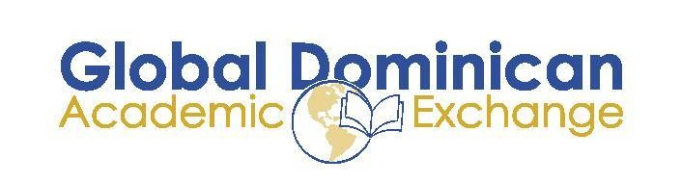

Global Dominican Academic Exchange Program at Yale University
Program Information
“The Yale Experience”

When: October 9-16, 2016
Where: Yale University, New Haven, Connecticut
Capacity: 10 students
Cost (Estimated): USD$600.00 (airfare) + USD$500 (meals) = USD$1,800.00 per person
Application Deadline: September 16, 2016

Program Description:
The Global Dominican Academic Exchange Program at Yale University is a collaborative effort between the Global Foundation for Democracy and Development and Yale University. The program will bring Dominican university students studying diverse topics to Yale University for a week, where they will experience the daily life of a Yale student, attending classes and special seminars and social events designed to inspire multicultural exchange and intellectual conversation with students and faculty at one of the most prestigious institutions in the world. It provides a unique opportunity for academic and cultural exchange and growth to both enrolled Dominican students and hosting Yale students.

Dominican participants will live in dormitories with student hosts during the week, with whom they will be paired based on academic and extracurricular interests. By living with fellow undergraduates, participants will fully experience the life of a student at Yale. During the week, participants will attend University classes, club meetings and sporting events with their hosts. Other academic events, including panels and guest lectures, will also be organized by the host group at Yale in order to inspire cross-cultural debate and conversation. The program overlaps with the celebration of Hispanic History Month, and special events are planned to be celebrated on campus accordingly.

How to Apply:
Applications are due September 16, 2016 and must include the online application form, unofficial transcript, CV, copy of passport, copy of valid US Visa and a brief one-page essay in English describing why you are an ideal candidate for this program and how it will contribute to your academic and professional goals.
Any questions, please direct them to: gabriela@globalfoundationdd.org

